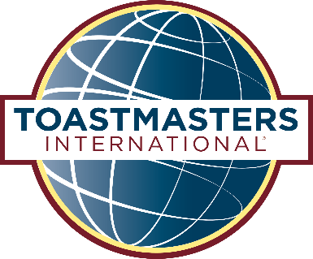

**AREA 00 Conference and Speech Contests**

**Saturday Oct 20th**

**8am – 1pm**

Cost $10.00 | RSVP Sat 13th October

**One registration and payment per Club**

Email name@yahoo.com.au

Direct Debit to ABC Club BSB 000-000 ACC 000-000

**Exploring New Horizons. TOGETHER.**

Area 00 Director Name Name warmly invites you to attend the 2018 Area 00 Conference and Speech Contests.

Cheer along your fellow members from Area 00:

* ABC Toastmasters Club
* DEF Toastmasters Club
* HIJ Toastmasters Club
* RST Toastmasters Club
* WXY Toastmasters Club

Location:

* 123 University, Bilinga
* Free parking on site
* See attached Site Map

Program:

* Registration 8am | Council Meeting 8.30am
* Evaluation Contest | Humorous Contest
* Morning Tea (Clubs bring a plate to share)
* Table Topics Contest | International Contest

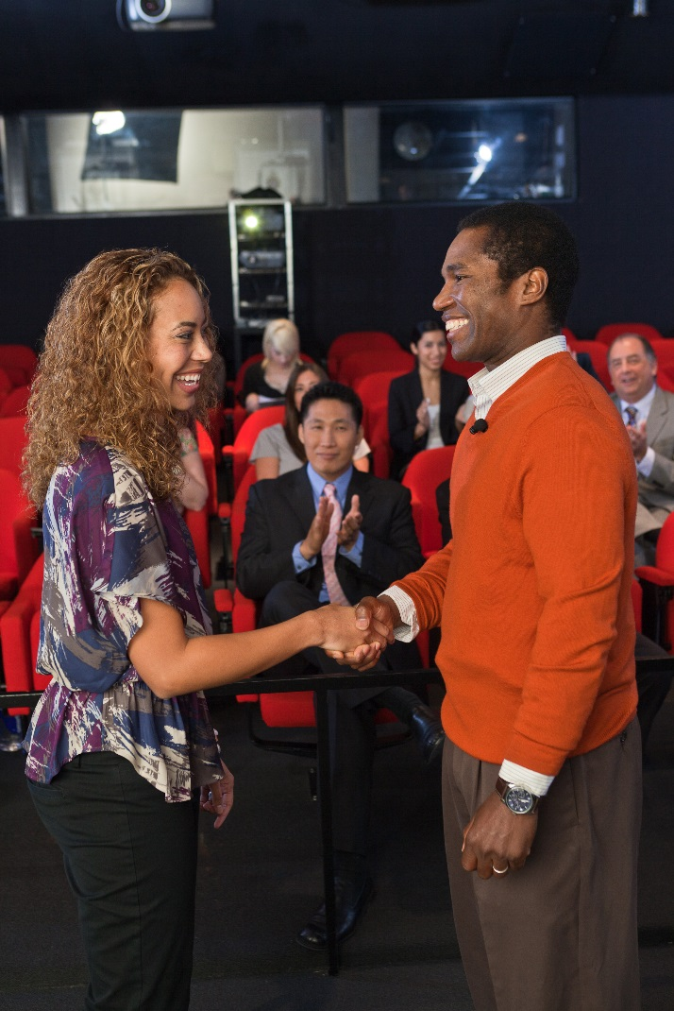



**Step Up. Reach Out. Connect.**

**AREA 35 Conference and Speech Contests**

**Saturday Oct 20th**

**8am – 1pm**

Cost $10.00 | RSVP Sat 13th October

**One registration and payment per Club**

Email didoig@yahoo.com.au

Direct Debit to Kings Club BSB 000-000 ACC 000-000

Area 35 Director Christiane Momberg warmly invites you to attend the 2018 Area 35 Conference and Speech Contests.

Cheer along your fellow members from Area 35:

* Elanora Early Morning Toastmasters Club
* Kings Toastmasters Club
* Leaders By Design Toastmasters Club
* Palm Beach Currumbin Toastmasters Club
* Southern Cross University Toastmasters Club

Location:

* Southern Cross University, Bilinga
* Building B, Rooms B328/B329 (blue building)
* Free parking on site

Program:

* Registration 8am | Council Meeting 8.30am
* Evaluation Contest | Humorous Contest
* Morning Tea (Clubs bring a plate to share)
* Table Topics Contest | International Contest

Page 2 Options

Keynote details

Detailed Program – briefing times etc.

Site Map (e.g. if at University)